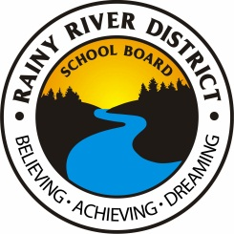
Detailed Project Proposal

For Facility Partnership

The eligible facility partners will be invited to submit this form to the Board for review.

Name of Organization:
Full Address:
Contact Name:
Position:
Contact Information: |  | Phone:
 |  | Cell:
 |  | E-mail:
Space Required (i.e. # rooms, washrooms, etc.). Specific requirements must be provided.

Parking Requirements

Renovations Required

Required Zoning Compliance or Amendments and Timelines

Financial Statements for Current and Past 5 Years

Willingness of partners to conduct public/community meetings advising the community of the use of the facility.

Yes No

If no – Comment:

Willingness of partners to work with the school community.

Yes No

If no – Comment:

Has independent insurance. (please attach)

Yes No

If no – Comment:

Meets requirement for criminal reference checks for all users/groups.

Yes No

If no – Comment:

Submitted by: |  |  |  | Date: | Click here to enter a date.
 | Signature
Print Name: |  |  |  | Title:

For more information, please contact:

Darlene Madill
Communications/Community Outreach Officer
Rainy River District School Board
dmadill@mail.rrdsb.com
(807) 274-9855 ext. 4989
Toll free 1-800-214-1753

